**Experiment No : 03**

**Title : Write a Python program to demonstrate math built-in functions (any two)**

**Problem statement :**

a. Use pi, calculate area of circle for a given radius.

b. Use any two in built math functions

c. Find roots of quadratic equations**.**

**Theory :**

**Math Functions :**

Python has a built-in module that you can use for mathematical tasks.The math module has a set of methods and constants.

|  |  |
| --- | --- |
| Method | Description |
| [math.acos()](https://www.w3schools.com/python/ref_math_acos.asp) | Returns the arc cosine of a number |
| [math.acosh()](https://www.w3schools.com/python/ref_math_acosh.asp) | Returns the inverse hyperbolic cosine of a number |
| [math.asin()](https://www.w3schools.com/python/ref_math_asin.asp) | Returns the arc sine of a number |
| [math.asinh()](https://www.w3schools.com/python/ref_math_asinh.asp) | Returns the inverse hyperbolic sine of a number |
| [math.atan()](https://www.w3schools.com/python/ref_math_atan.asp) | Returns the arc tangent of a number in radians |
| [math.atan2()](https://www.w3schools.com/python/ref_math_atan2.asp) | Returns the arc tangent of y/x in radians |
| [math.atanh()](https://www.w3schools.com/python/ref_math_atanh.asp) | Returns the inverse hyperbolic tangent of a number |
| [math.ceil()](https://www.w3schools.com/python/ref_math_ceil.asp) | Rounds a number up to the nearest integer |
| [math.comb()](https://www.w3schools.com/python/ref_math_comb.asp) | Returns the number of ways to choose k items from n items without repetition and order |
| [math.copysign()](https://www.w3schools.com/python/ref_math_copysign.asp) | Returns a float consisting of the value of the first parameter and the sign of the second parameter |
| [math.cos()](https://www.w3schools.com/python/ref_math_cos.asp) | Returns the cosine of a number |
| [math.cosh()](https://www.w3schools.com/python/ref_math_cosh.asp) | Returns the hyperbolic cosine of a number |
| [math.degrees()](https://www.w3schools.com/python/ref_math_degrees.asp) | Converts an angle from radians to degrees |
| [math.dist()](https://www.w3schools.com/python/ref_math_dist.asp) | Returns the Euclidean distance between two points (p and q), where p and q are the coordinates of that point |
| [math.erf()](https://www.w3schools.com/python/ref_math_erf.asp) | Returns the error function of a number |
| [math.erfc()](https://www.w3schools.com/python/ref_math_erfc.asp) | Returns the complementary error function of a number |
| [math.exp()](https://www.w3schools.com/python/ref_math_exp.asp) | Returns E raised to the power of x |
| [math.expm1()](https://www.w3schools.com/python/ref_math_expm1.asp) | Returns Ex - 1 |
| [math.fabs()](https://www.w3schools.com/python/ref_math_fabs.asp) | Returns the absolute value of a number |
| [math.factorial()](https://www.w3schools.com/python/ref_math_factorial.asp) | Returns the factorial of a number |
| [math.floor()](https://www.w3schools.com/python/ref_math_floor.asp) | Rounds a number down to the nearest integer |
| [math.fmod()](https://www.w3schools.com/python/ref_math_fmod.asp) | Returns the remainder of x/y |
| [math.frexp()](https://www.w3schools.com/python/ref_math_frexp.asp) | Returns the mantissa and the exponent, of a specified number |
| [math.fsum()](https://www.w3schools.com/python/ref_math_fsum.asp) | Returns the sum of all items in any iterable (tuples, arrays, lists, etc.) |
| [math.gamma()](https://www.w3schools.com/python/ref_math_gamma.asp) | Returns the gamma function at x |
| [math.gcd()](https://www.w3schools.com/python/ref_math_gcd.asp) | Returns the greatest common divisor of two integers |
| [math.hypot()](https://www.w3schools.com/python/ref_math_hypot.asp) | Returns the Euclidean norm |
| [math.isclose()](https://www.w3schools.com/python/ref_math_isclose.asp) | Checks whether two values are close to each other, or not |
| [math.isfinite()](https://www.w3schools.com/python/ref_math_isfinite.asp) | Checks whether a number is finite or not |
| [math.isinf()](https://www.w3schools.com/python/ref_math_isinf.asp) | Checks whether a number is infinite or not |
| [math.isnan()](https://www.w3schools.com/python/ref_math_isnan.asp) | Checks whether a value is NaN (not a number) or not |
| [math.isqrt()](https://www.w3schools.com/python/ref_math_isqrt.asp) | Rounds a square root number downwards to the nearest integer |
| [math.ldexp()](https://www.w3schools.com/python/ref_math_ldexp.asp) | Returns the inverse of [math.frexp()](https://www.w3schools.com/python/ref_math_frexp.asp) which is x * (2**i) of the given numbers x and i |
| [math.lgamma()](https://www.w3schools.com/python/ref_math_lgamma.asp) | Returns the log gamma value of x |
| [math.log()](https://www.w3schools.com/python/ref_math_log.asp) | Returns the natural logarithm of a number, or the logarithm of number to base |
| [math.log10()](https://www.w3schools.com/python/ref_math_log10.asp) | Returns the base-10 logarithm of x |
| [math.log1p()](https://www.w3schools.com/python/ref_math_log1p.asp) | Returns the natural logarithm of 1+x |
| [math.log2()](https://www.w3schools.com/python/ref_math_log2.asp) | Returns the base-2 logarithm of x |
| [math.perm()](https://www.w3schools.com/python/ref_math_perm.asp) | Returns the number of ways to choose k items from n items with order and without repetition |
| [math.pow()](https://www.w3schools.com/python/ref_math_pow.asp) | Returns the value of x to the power of y |
| [math.prod()](https://www.w3schools.com/python/ref_math_prod.asp) | Returns the product of all the elements in an iterable |
| [math.radians()](https://www.w3schools.com/python/ref_math_radians.asp) | Converts a degree value into radians |
| [math.remainder()](https://www.w3schools.com/python/ref_math_remainder.asp) | Returns the closest value that can make numerator completely divisible by the denominator |
| [math.sin()](https://www.w3schools.com/python/ref_math_sin.asp) | Returns the sine of a number |
| [math.sinh()](https://www.w3schools.com/python/ref_math_sinh.asp) | Returns the hyperbolic sine of a number |
| [math.sqrt()](https://www.w3schools.com/python/ref_math_sqrt.asp) | Returns the square root of a number |
| [math.tan()](https://www.w3schools.com/python/ref_math_tan.asp) | Returns the tangent of a number |
| [math.tanh()](https://www.w3schools.com/python/ref_math_tanh.asp) | Returns the hyperbolic tangent of a number |
| [math.trunc()](https://www.w3schools.com/python/ref_math_trunc.asp) | Returns the truncated integer parts of a number |

**Code :**

1. **Use pi, calculate area of circle for a given radius.**

import math

r=*int*(input('enter radius of the cirle : '))

pi=math.pi

area=pi*r*r

print('area of a circle is ',area)

**output :**

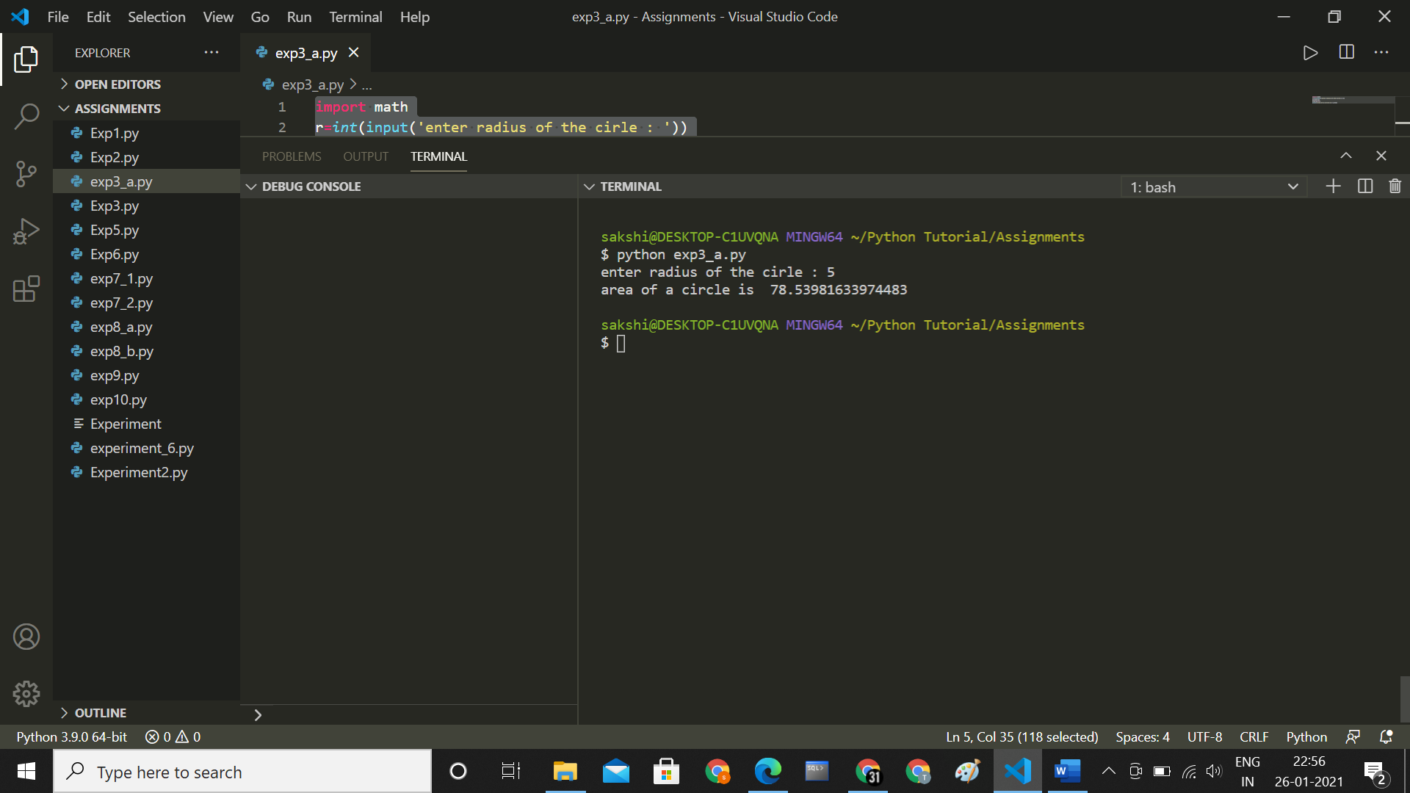

**b. Use any two in built math functions**

import math

a ,b=input("enter two numbers sepreated by single space :").split()

a=*int*(a)

b=*int*(b)

print("Square root of ",a," is : ",math.sqrt(a))

print("Square root of ",b, " is : ",math.sqrt(b))

print(a," raised to power ",b," is : ",math.pow(a,b))

**output :**

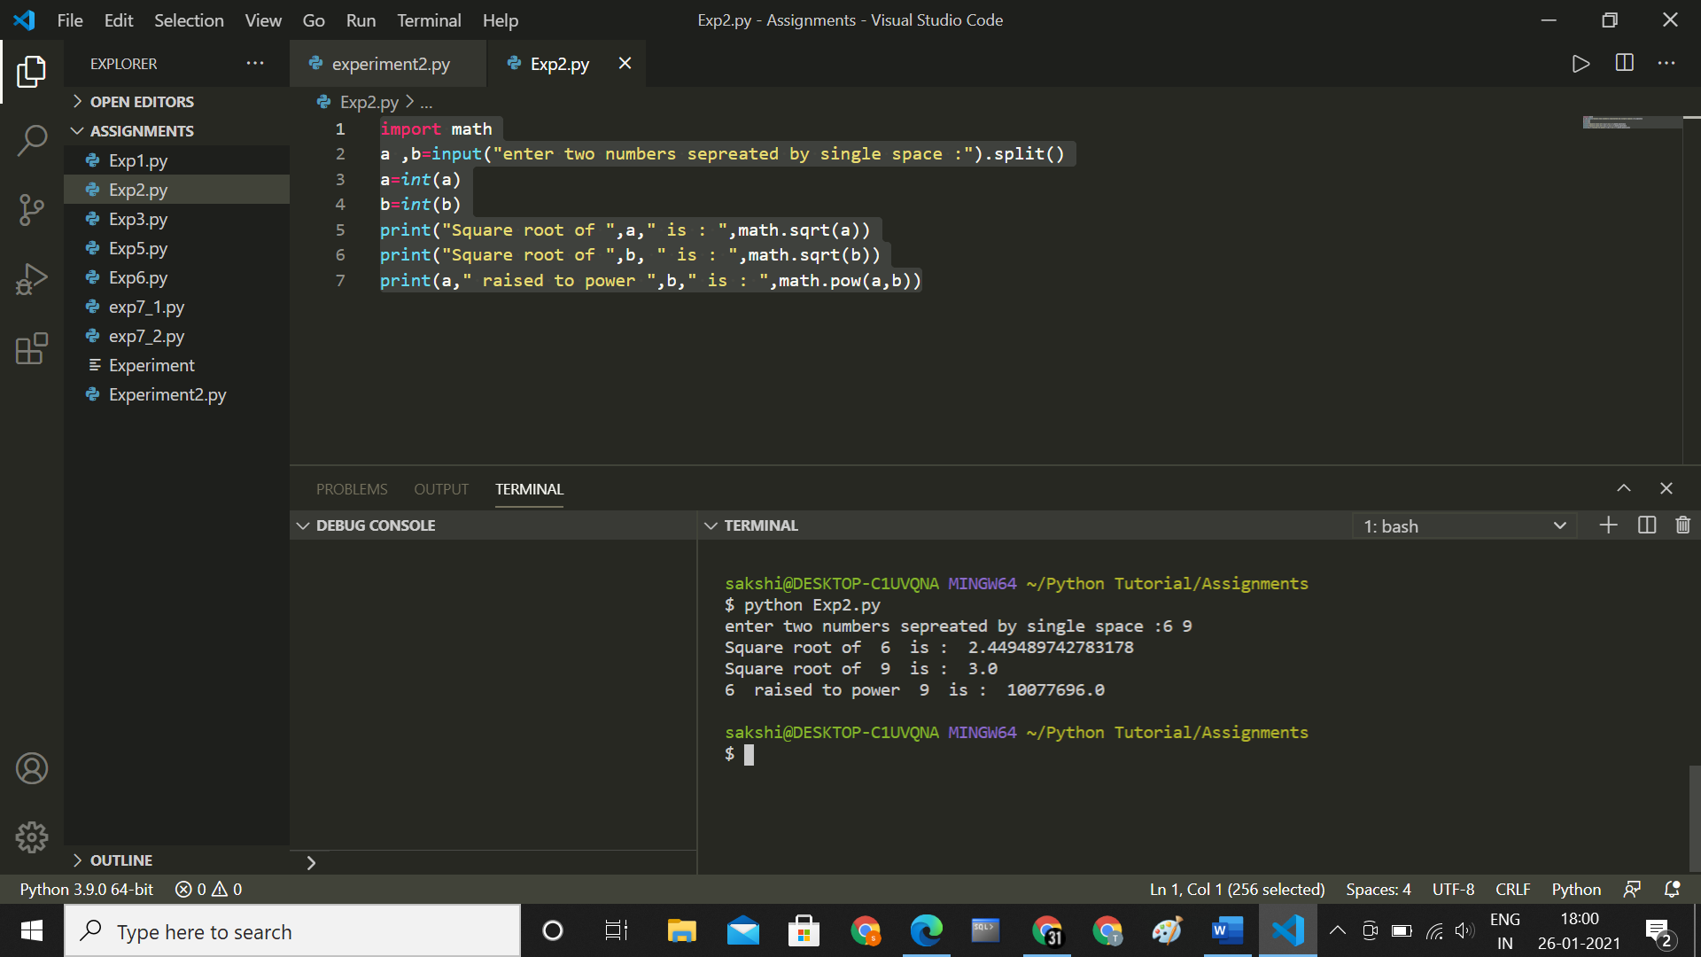

**c.Find roots of quadratic equations.**

import cmath

a = 1

b = 5

c = 6

# calculate the discriminant

d = (b**2) - (4*a*c)

# find two solutions

sol1 = (-b-cmath.sqrt(d))/(2*a)

sol2 = (-b+cmath.sqrt(d))/(2*a)

print(sol1, ' and ',sol2,'are the roots of the given quadratic euquation')

**output :**

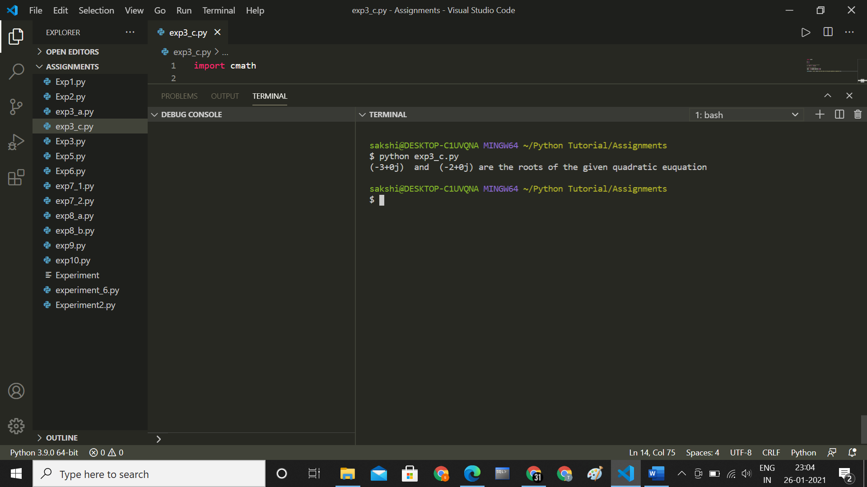

**Conclusion :**

**Thus we have understood how to Write a Python program to demonstrate math built-in functions**